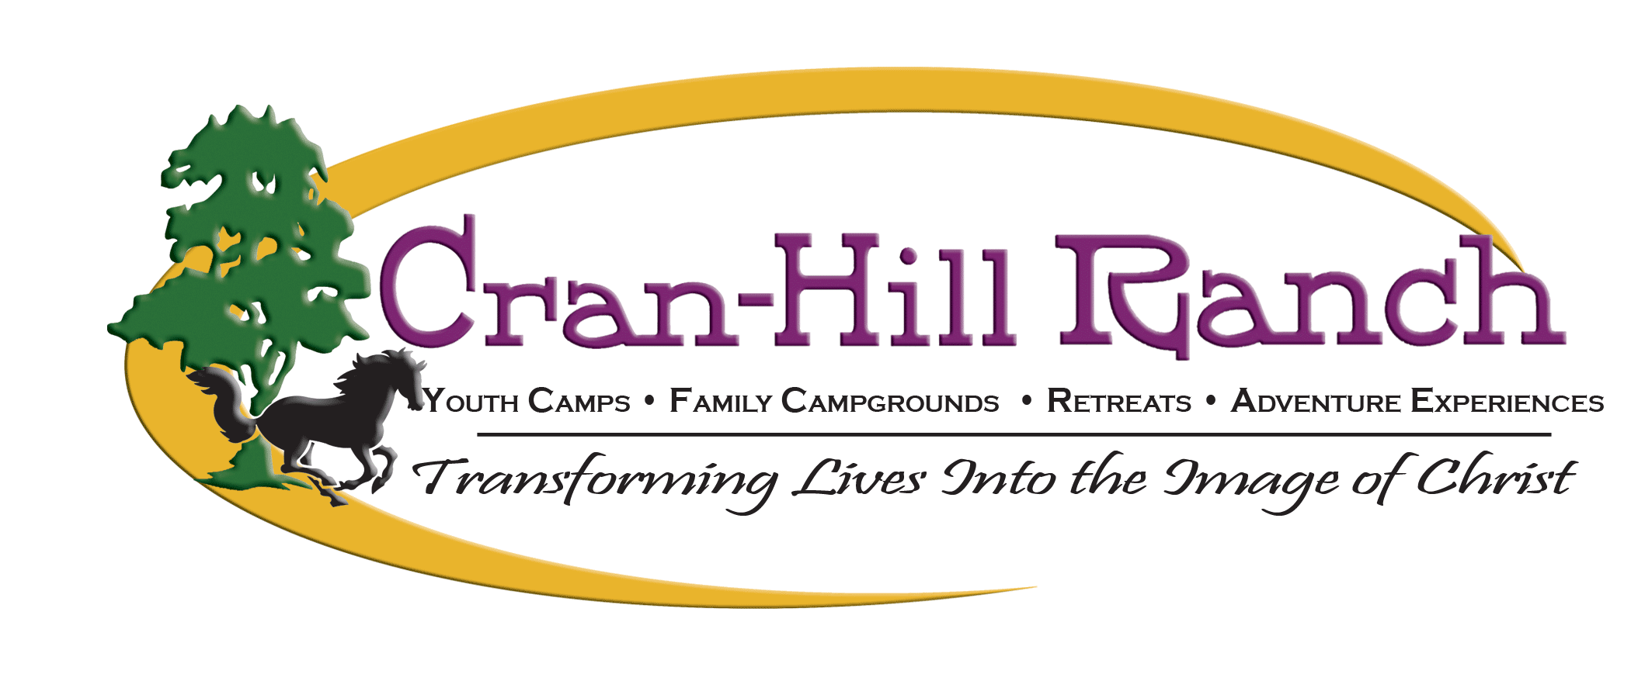
Guest Liability Waiver
& Assumption of Risk

General Use of Property
I understand that by being permitted on the premises of Cran-Hill Ranch, I may engage in activities or utilize the premises or property in a way that may involve inherent risks that are beyond the control of Cran-Hill Ranch. Cran-Hill Ranch has taken precautions to provide a safe setting, but I understand that the possibility of injury, death, or loss to persons is present. Activities may include, but are not limited to, physical activity, walking/running, group games, sports, aquatic activities, general recreation, and general use of grounds.

By signing below, I hereby give consent for the below mentioned participants to use the grounds and activities.

Equine Related Activities
In consideration of being permitted to participate among and on horses on the premises of or under the auspices of Cran-Hill Ranch, on my behalf and/or on the behalf of the participants named below acknowledge, appreciate, and agree that engaging in equine activities involves inherent risks including, but not limited to, the following:
- The propensity of an equine to behave in ways (such as, but not limited to, buck, stumble, fall, rear, bite, kick, run, and make unpredictable movements, spook, jump obstacles, step on a person’s feet, push or shove a person, saddles or bridles may loosen or break) all of which may result in injury, death, or loss to persons on or around the equine;
- The potential of an equine activity participant to act in a negligent manner that may contribute to injury, death, or loss to the person of the participant or to other persons, including, but not limited to, failing to maintain control over an equine or failing to act within the ability of the participant.

Risks to Unborn Children: Because of the inherent risks of riding horses to the safety of unborn children, Cran-Hill Ranch advises pregnant women not to ride horses.

Under the Michigan Equine Activity Liability Act, an equine professional is not liable for an injury to or the death of a participant in an equine activity resulting from an inherent risk of the equine activity.

By signing below, I hereby give consent for the below mentioned participants to engage in equine activities.

High Adventure Activities
High Adventure activities include, but are not limited to, the following: High Ropes Course, Low Ropes Course, Team Building, Target Sports, Swimming, Boating, Watersports, Bicycling, Skate Park, River or Lake Tubing, Ice Climbing, Cross-Country Skiing, Snowshoeing, Ice Skating, Broomball, Snow Tubing/Sledding, and Running/Race Events. I understand that while participating in High Adventure activities at Cran-Hill Ranch I may be exposed to psychologically and physically stressful and challenging situations, all of which may result in injury, death, or loss to persons.

By signing below, I hereby give consent for the below mentioned participants to engage in high adventure activities.

Assumption of Risk
I understand that although Cran-Hill Ranch has taken precautions to provide proper organization, supervision, instruction, and equipment for each activity, that absolute safety is impossible to guarantee. I understand that this is largely due to the fact that I share in the responsibility for my own safety. I accept this responsibility. Knowing that an accident could cause serious injury or death, I waive any claim that may arise against Cran-Hill and/or its employees as a result of my participation in the program.

I knowingly and freely assume all such risks, both known and unknown; even if arising from the ordinary negligence of those persons released from liability below, and assume full responsibility for my participation; and, I will comply with all rules and regulations. If I have any question, or observe any unusual or unnecessary hazard during my participation, I will immediately bring such to the attention of the nearest official; and, I certify that I do not suffer from any infirmities or illnesses which would affect my ability to participate in the above described activities.
With full knowledge of the above and any other inherent risks which may be associated with the above activities, I hereby consent, and grant permission to any dependent minors listed below, to participate in the above described activities, and I agree to release, discharge, promise not to sue and waive any and all claims for personal injury, disability, death, or property damage of any kind which my children, I or my heirs, personal representatives and next of kin may have or which may arise against Cran-Hill Ranch as a result of participating in such activities, whether or not such injuries or damages result from negligence, to the fullest extent permitted by law. Except in the event of gross and willful negligence, on behalf of my children herein listed, myself, my heirs, personal representatives, and next of kin, I hereby release and discharge Cran-Hill Ranch, its successors, assigns, affiliates, directors, officers, employees, and agents from any and all liabilities, claims, lawsuits, losses, costs, causes of action and damages of any kind originating or in any way arising from participating in such activities. I further agree to indemnify and hold harmless Cran-Hill Ranch, its successors, assigns, affiliates, directors, officers, employees, and agents from any and all claims, demands, or actions brought by or on behalf of my child notwithstanding my release of such claims on his or her behalf.

Photo Release
I certify that photographs or videotape pictures of me or my children participating in the Cran-Hill programs may be reproduced and utilized in promotional materials for the camp.

Guest Information
Complete the following information for every member of your household visiting the premises of Cran-Hill Ranch, or participating in a program or event organized and facilitated by Cran-Hill Ranch.

_________________________________________ _____________________________________
1st Adult First & Last Name Child’s Name Age

_________________________________________ _____________________________________
2nd Adult First & Last Name Child’s Name Age

_________________________________________ _____________________________________
Address Child’s Name Age

_________________________________________ _____________________________________
City State Zip Child’s Name Age

Home Phone (________) ______________________ _____________________________________
Child’s Name Age

Cell Phone (________) _______________________ _____________________________________
Child’s Name Age

Email ____________________________________________________________________________

Signature
By signing below, I represent that I am at least eighteen (18) years of age and am the parent or legal guardian of the above mentioned minors. I am under no mental or legal disability which would prevent me from signing and executing this agreement. I further represent that I have read (or have had read to me) and understood the terms of this agreement.

_________________________________________________ __________________________
1st Adult Signature Date

_________________________________________________ __________________________
2nd Adult Signature Date

